ACCUFIRE MULTIFUNCTIONAL SIGHT

NOCTIS V1

Product Specification

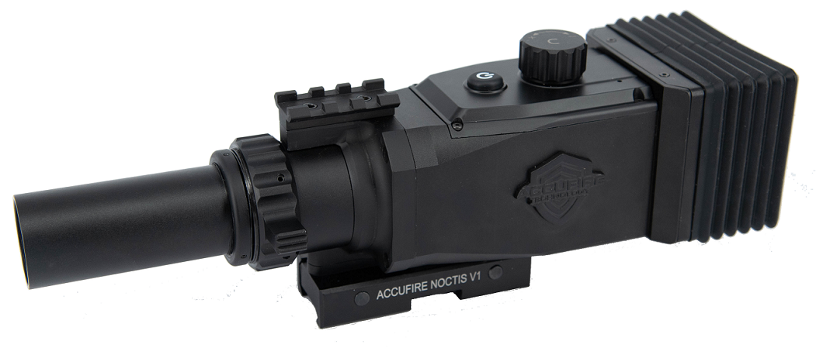



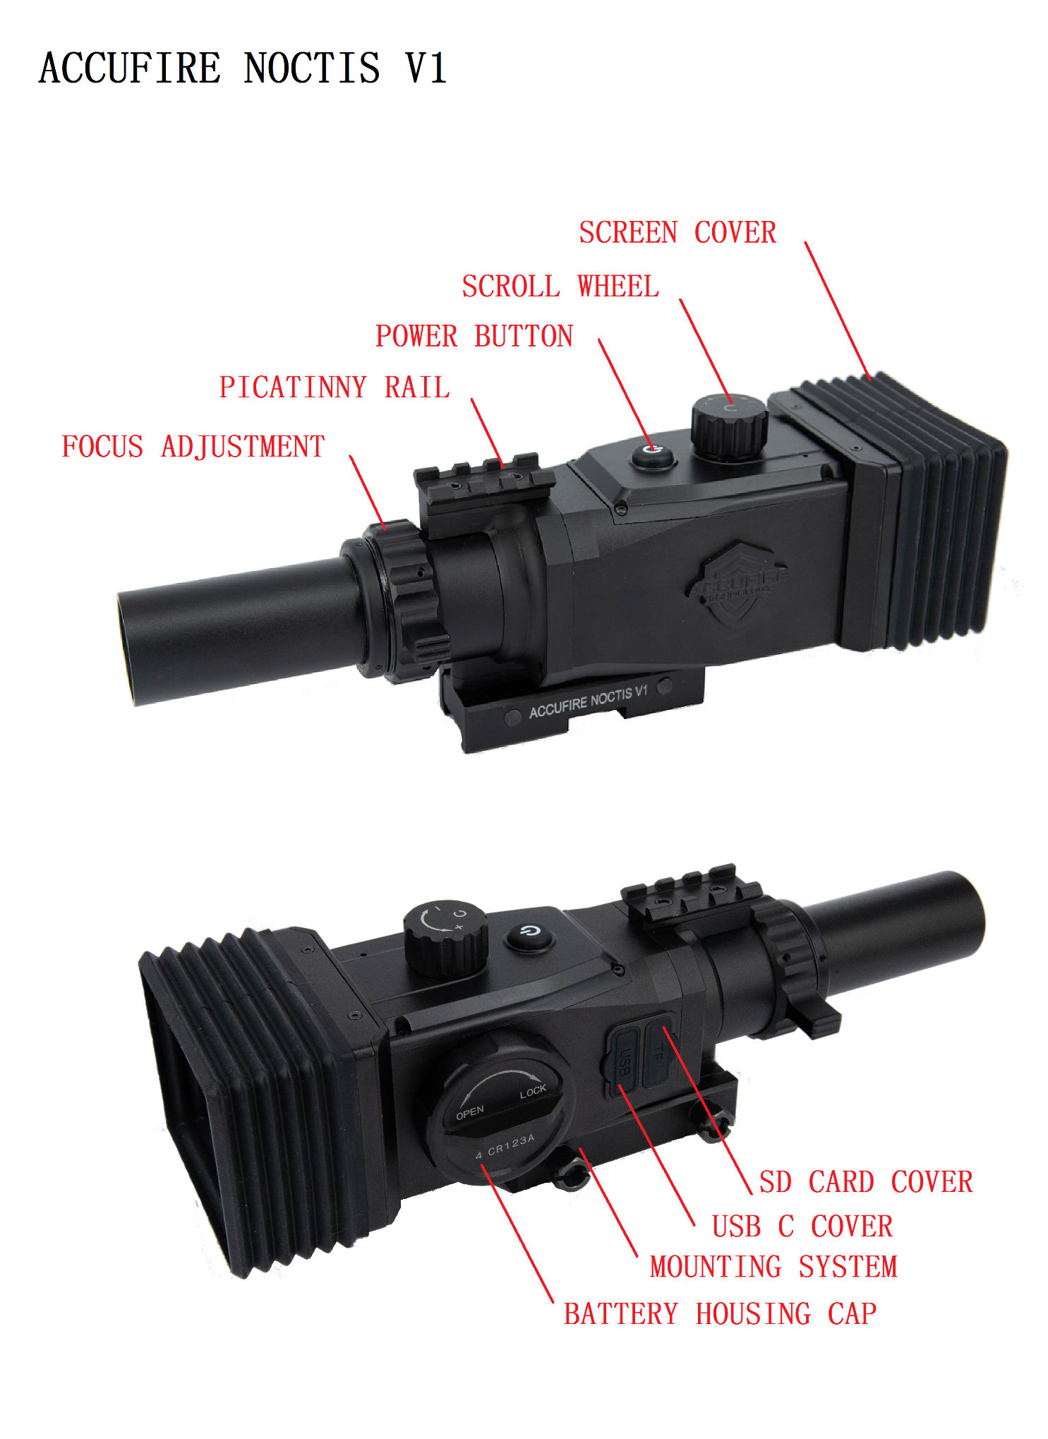
Contents
Product Features 3
Operating Instructions 4
Unpacking Inspection 4
Product Power Supply 4
Micro SD Socket 5
Startup & Shutdown 5
Power Button and Knob 5
Focus Adjustment 6
Installation 6
Interfaces 7
Home Screen 7
Menu Item 8
Functions 9
Primary Magnification 9
Distance 10
Sighting Area Magnification 10
Zeroing 11
Hunting/Observing Mode 12
Reticle Style 13
Sleep 13
Factory Reset 14
Software Upgrade 14
Day and Night Mode Switching 15
Bullet Type Input 15
System settings 16
WiFi Setting 16
Sighting Window Opening 16
Screen Brightness Setting 17
Time Setting 18
Mobile Application 19

Product Features

- 1080P HD Video
- High-Precision Trajectory Calculation
- Quick Calibration
- 3.8-23 Times Smooth Zooming
- Three-Axis Gyroscope
- Three-Axis Accelerometer
- Day and Night Mode Switching
- WiFi Video Image Transmission
- AMOLED HD Screen Display

Product Specification
Microphone | Yes | Micro SD card | 2-32Gb
Ports | USB type C、Micro SD | battery type | 4 CR123A
Dimensions | 196*85*87mm | Weight | 31 oz/1.6lb
IP rating | IPX4 | Battery Life | 5 hours
Mounting | Picatinny | Warranty | 2 years

Operating Instructions

Unpacking Inspection
Please follow the steps below before using the sight:
1. Take the sight out from the packing box.
2. Check whether there are accessories: sight, light shield, hood, filter cartridge, TYPE-C data cable and micro USB data cable.
3. Before use, please ensure that the surface of the lens is smooth.

Product Power Supply
The sight can be powered by a battery or a mobile power source, and when both power sources are present, powered preferably by the mobile power supply.

Battery Power Supply:
Install 4 CR123A batteries and tighten the battery cover.

Mobile Power Source Power
Supply:
Connect the sight with the mobile power using the TYPE-C data cable

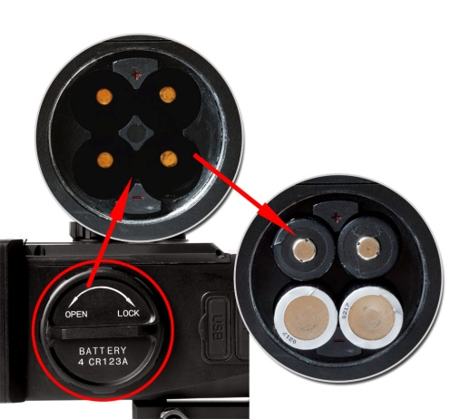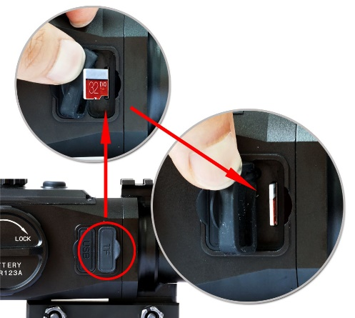

Micro SD Socket
Please be sure to insert the SD card before using the sight to ensure that the sight functions properly.
Uncover the rubber plug and insert the micro SD card as shown.

Startup & Shutdown
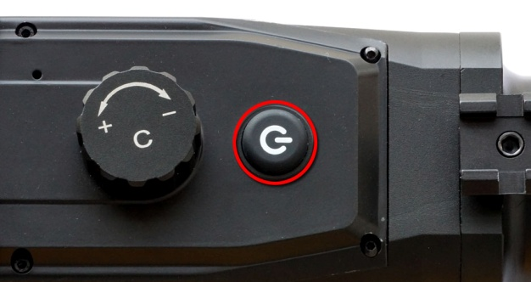
Start up the device: press and hold the power button until the ACCUFIRE icon appears on the screen.
Shut down the device: press and hold the power button until the screen is turned off.

Power Button and Knob

Three operating modes of
power button:
Short-press 1 time: take photo
Short-press 2 times: start video
Long-press: startup & shutdown
Three operating modes of knob:
Rotate: switch option
Short-press: enter option
Long-press: enter or quit main menu

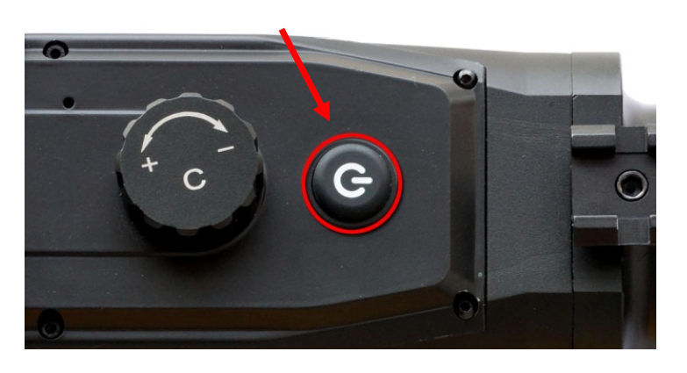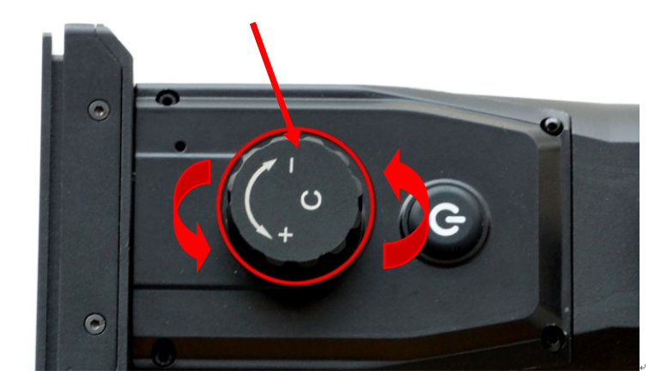

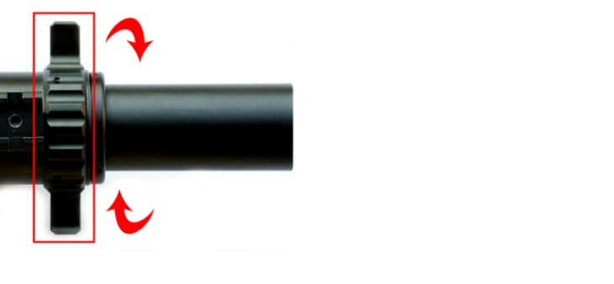
Focus Adjustment
Rotate the focus knob to ensure that a clear picture may be presented at any distance.

Installation
- Unscrew two nuts on the mount.
- Place the sight on the appropriate position of the Picatinny rail.
- Tighten the retaining nut.

Loose
Tight

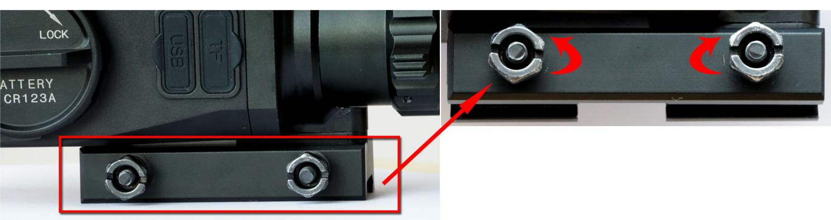

Interfaces

Home Screen
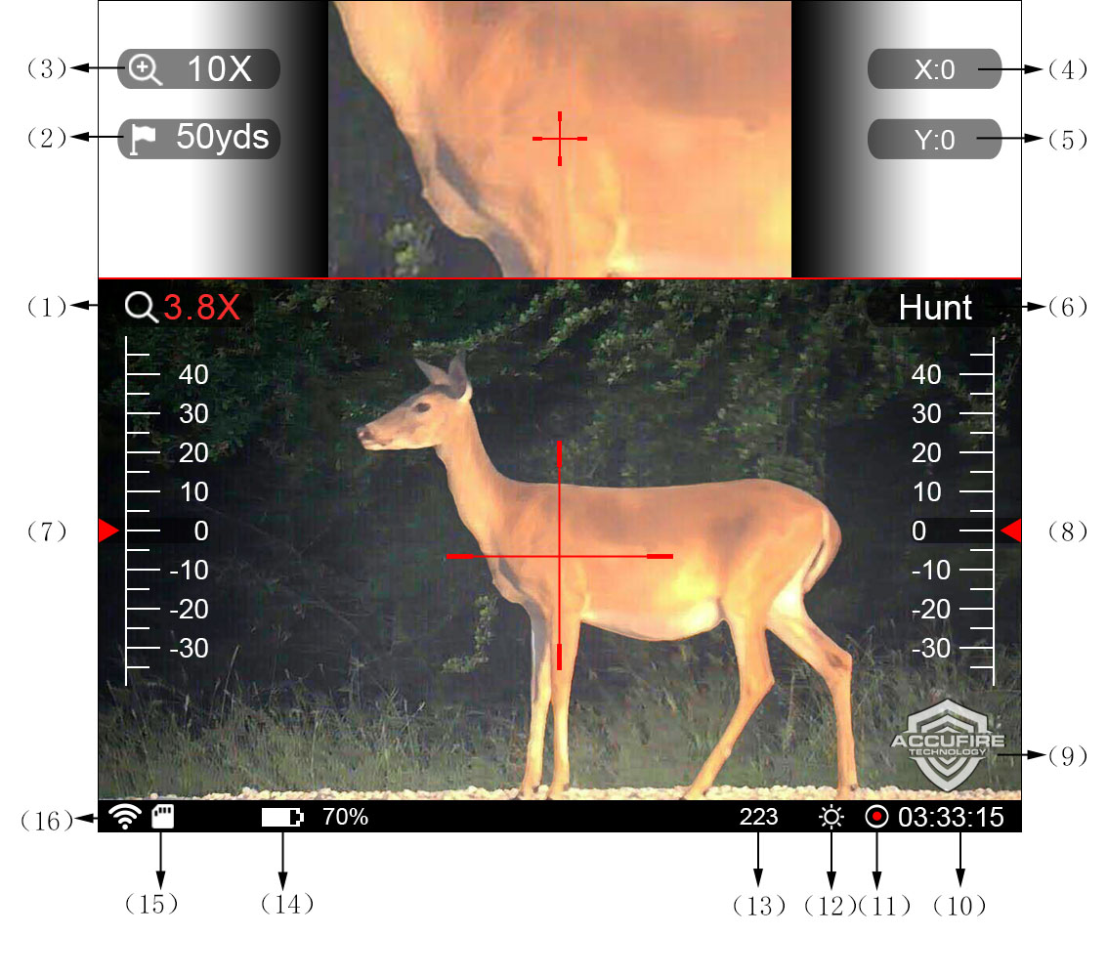
No. | Name | Functions
1 | Home screen magnification | Edit and display current magnification of the sight
2 | Distance | Edit and display current distance of the target
3 | Sighting area magnification | Edit and display current magnification of the sighting area
4 | Horizontal trajectory compensation | Edit and display horizontal trajectory compensation at the current distance
5 | Vertical trajectory compensation | Edit and display vertical trajectory compensation at the current distance
6 | Hunting/observing mode | Switch between hunting and observing modes
7 | Pitch angle scale | Display attitude pitch angle scale
8 | Roll angle scale | Display attitude roll angle scale
9 | Logo | Display product logo
10 | Time display | Display cumulative time of video during video, and display the current time during non-video
11 | Video indicator | Flicker during video
12 | Day and night mode display | Prompt to use day/night mode currently
13 | Bullet category | Display the currently used bullet category
14 | Battery level | Flicker at low battery level and prompt the remaining time
15 | SD card identifier | Indicate whether the SD card exists
16 | Wifi identifier | whether the WiFi is opened

Menu Item
Long-press the knob, and release the knob after the home menu interface appears. There are 7 menu items in total, and various menu items can be cyclically switched by rotating the knob.
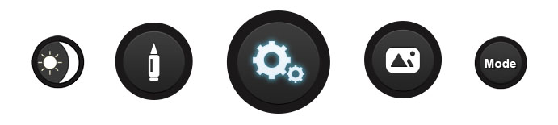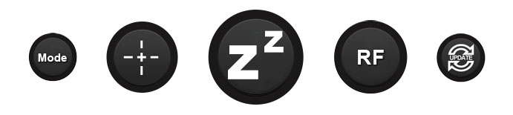
Pattern | Description
 | Reticle Style 10: click the knob to select the cross division line style
 | Sleep: click the knob to make the sight enter the sleep mode and turn off the screen
 | Range finder: click to enter the range configuration interface; turn on or off the range function, and select the range target.
 | Software upgrade: click the knob to make the sight read the upgrade file from the SD card and perform the software upgrade.
 | Day and night mode switch: click the knob to switch day and night vision modes
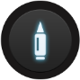 | Bullet type: click and enter the bullet type management interface, you can select, add, and delete bullet lines.
 | System setting: click the knob to set the time, battery type, sighting area, wifi, screen brightness and factory reset
 | Picture preview: preview the pictures that have been shot.
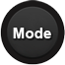 | Mode selection: select setting to use Traditional mode or Ballistic mode.

Functions

Primary Magnification
Rotate the knob to select “Primary Magnification”, click to enter the edit mode, rotate the knob to adjust the primary magnification from 3.8x to 4.2x to magnify the image, otherwise reduce the image. When the magnification reaches 11.6 times and above, the sighting crossline will be automatically thickened.
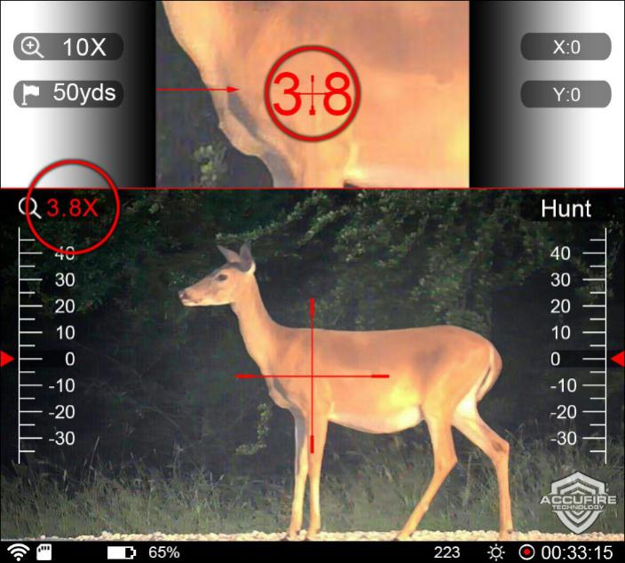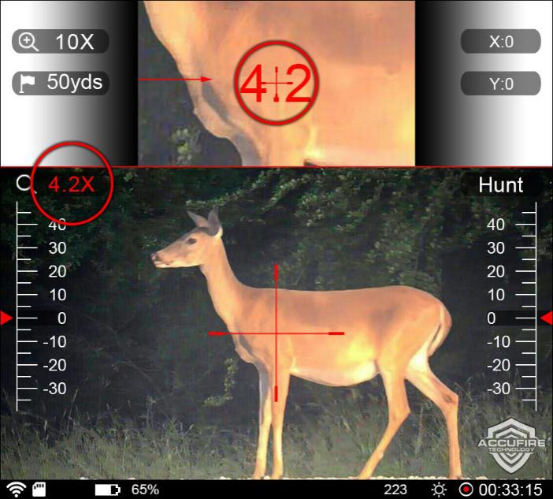
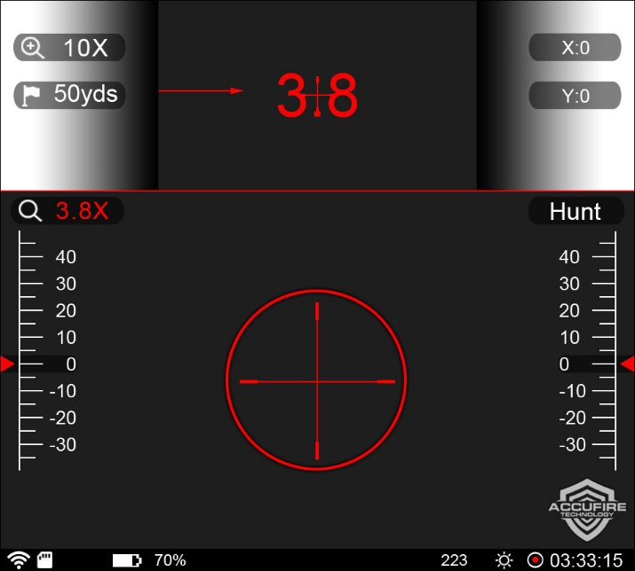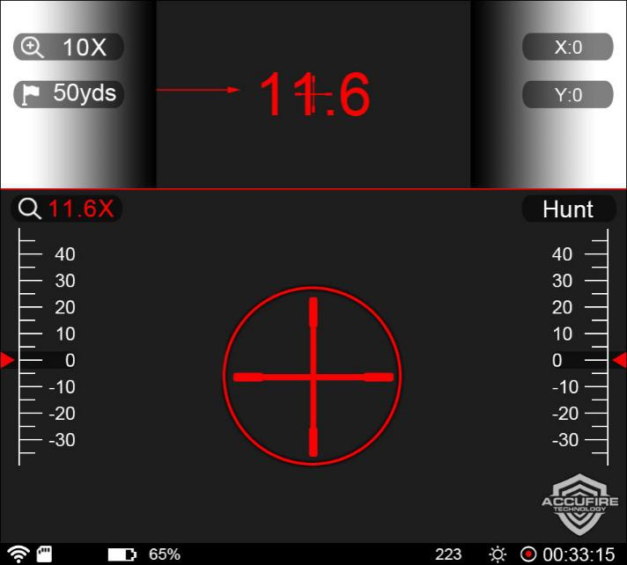

Distance
Rotate the knob to select the distance option, click the knob to set the distance value, and rotate the knob to increase or decrease the distance value. With the ranging function on, rotate the knob for real-time ranging.
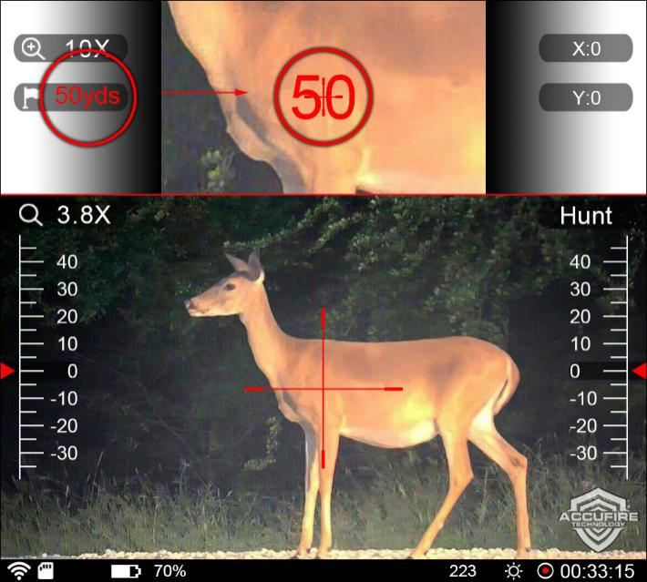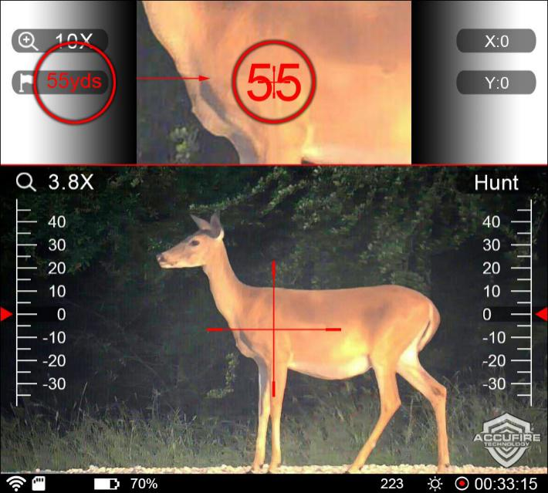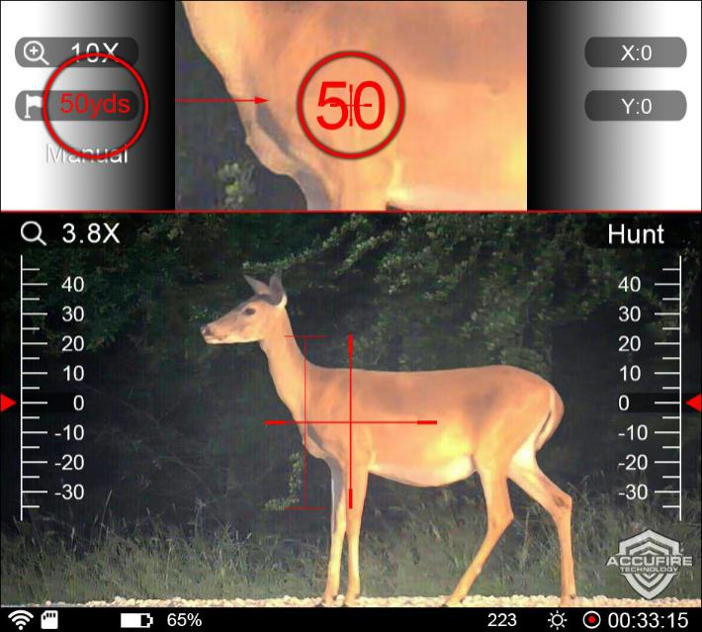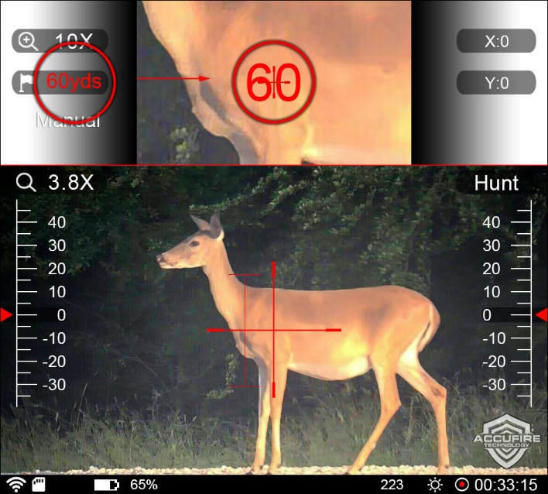

Sighting Area Magnification
Rotate the knob to select the sighting area magnification option, click the knob to set the sighting area magnification, and rotate the knob to increase or decrease the sighting area magnification.
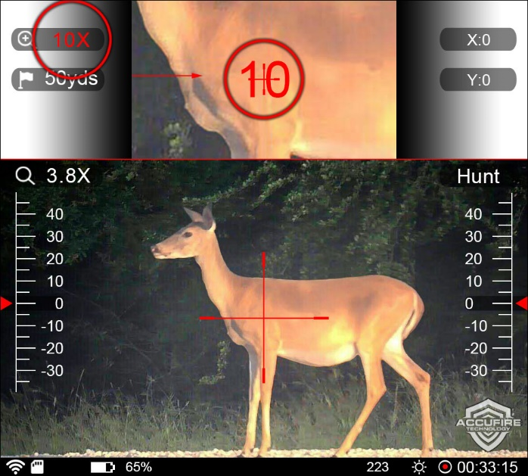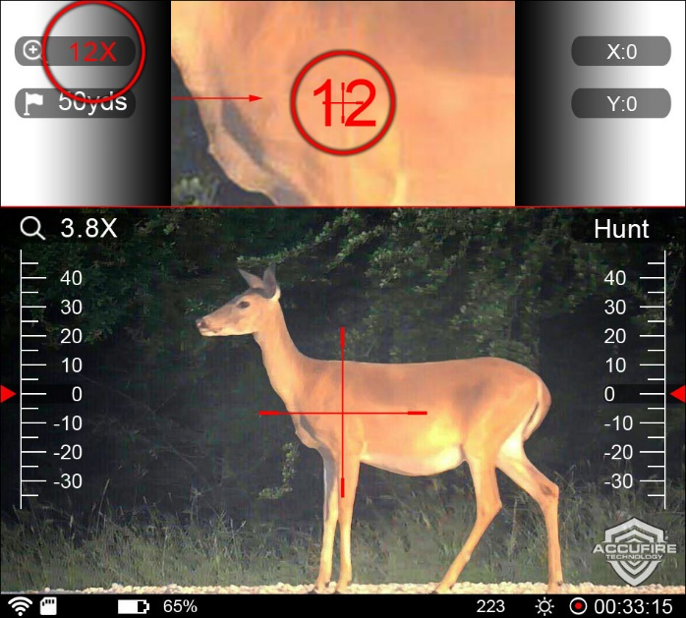

Zeroing
Set up a target at 50 yards and change distance on scope to 50 yards. Fire one shot at 50 yards and record where the bullet strikes the target on the X and Y axis. Input the X value(Inch) of shot into the X setting on the scope and then do same for Y. Fire a second shot after first shot has been entered on scope. If the second shot doesn’t direct hit the center of target, record the 2nd shot and enter the coordinates in the X and Y settings on scope again, and then fire the 3rd shot. Continue these steps until your bullet strikes the center of target.

Once zeroed at 50 yards, adjust the target to 100 yards and change distance on scope to 100 yards, and repeat above steps until you strike center of the target.

During the zeroing process, input the correct value according to the deviation position of the impact point. When the value is input, the interface indicates that the direction of the input value is in the target center, including Left, Right, Up and Down.
For video instructions please visit www.youtube.com/accufiretech
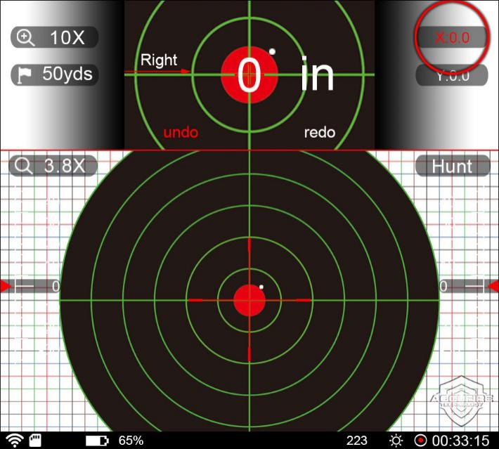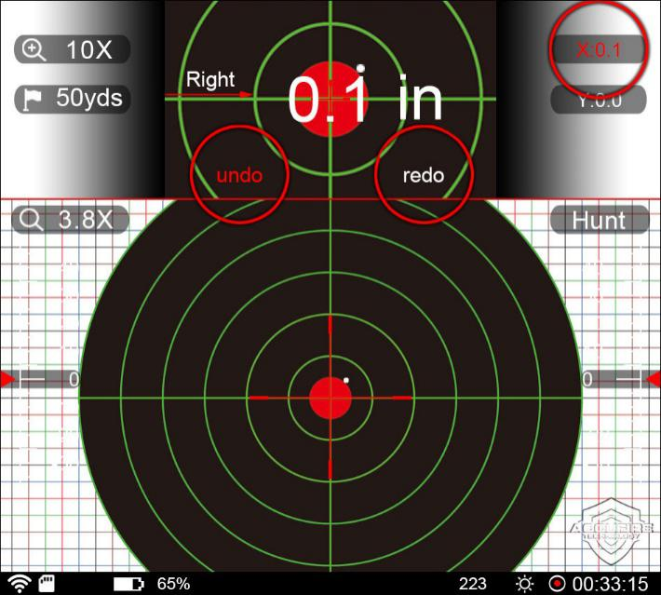
During zeroing, if the input is wrong or mishandled, you can undo or redo.

Hunting/Observing Mode
The default is the hunting mode. This option will be selected and the modes will be cyclically switched by clicking the knob. In the observing mode, the cross division line and bullet types will not be displayed.

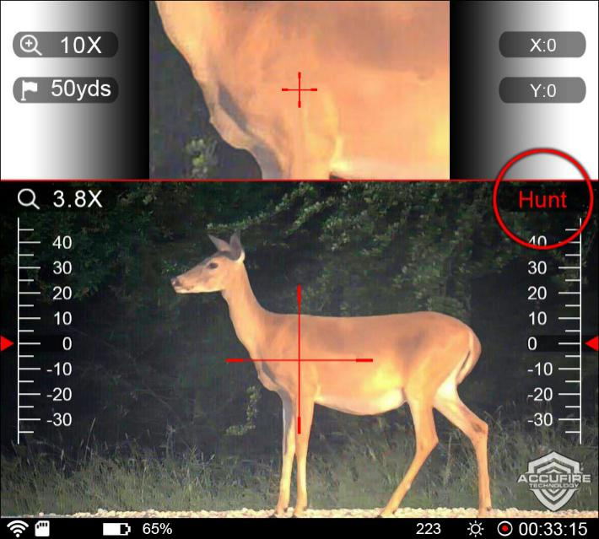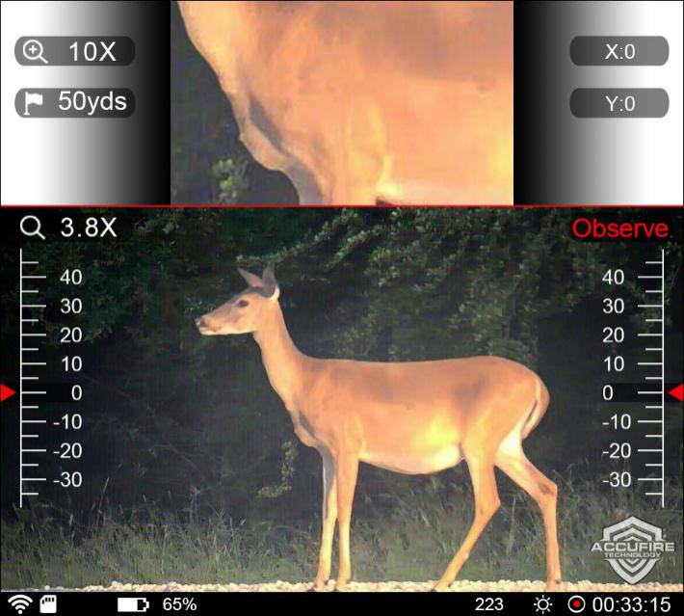

Reticle Style
Enter the home menu item, select the reticle style, Enter the cross pattern in the main menu, rotate the knob to select the cross, click to enter the cross selection interface, rotate the knob to switch the cross pattern, click to select and return to the main interface. At this point, if the ranging function is enabled, the color of the ranging ruler line and the selected cross color will be automatically switched to the same; in the cross selection interface, if you do not make any selection on cross pattern, long press to exit.
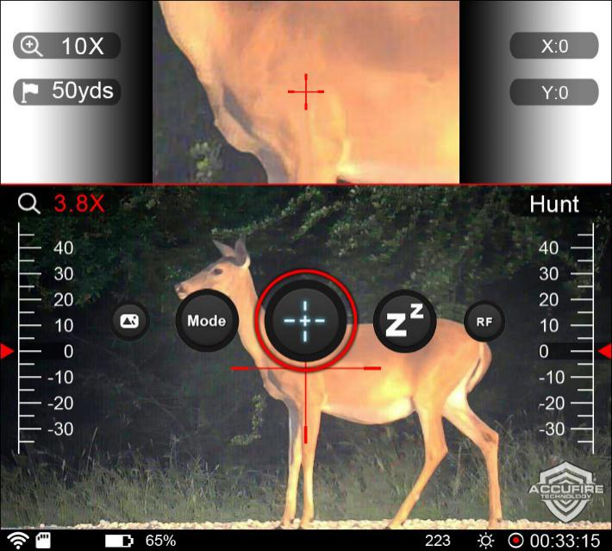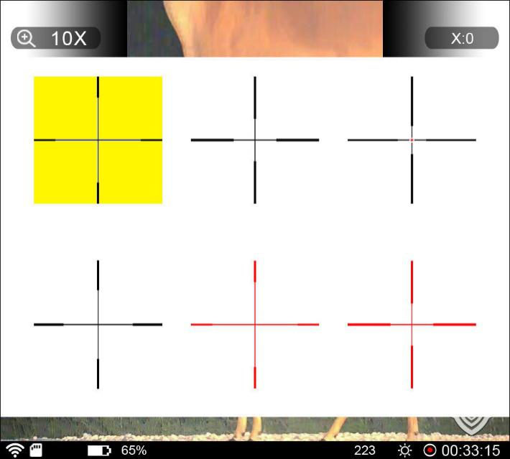
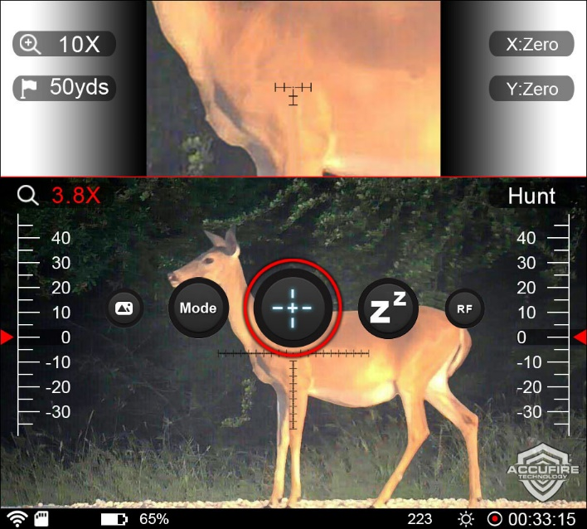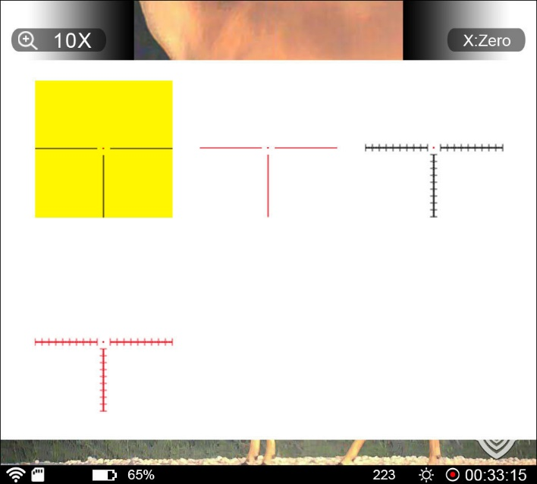

Sleep
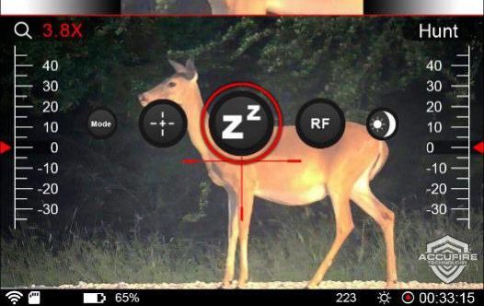
Enter the home menu item, select the sleep icon, and click the knob, the sight enters the sleep mode, and in the sleep mode, quits the sleep mode by clicking the power button.

Range finder
Click the ranging icon.
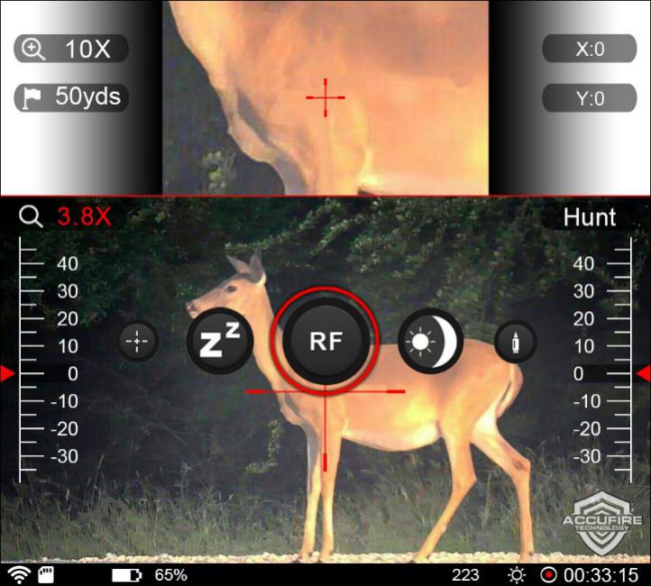
Click “ranging” to display the setting interface. Click “off” to switch to “on” and display the height list of the target object, and the unit is inch. “Manual” means to set manually which is used when the target object is not in the list; there are data of various targets, which can be chosen through knob switch.
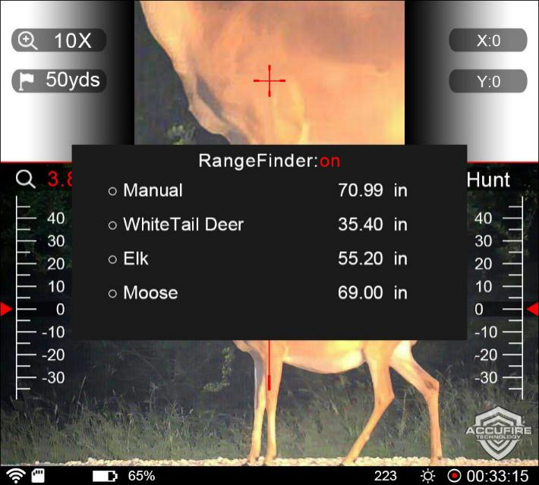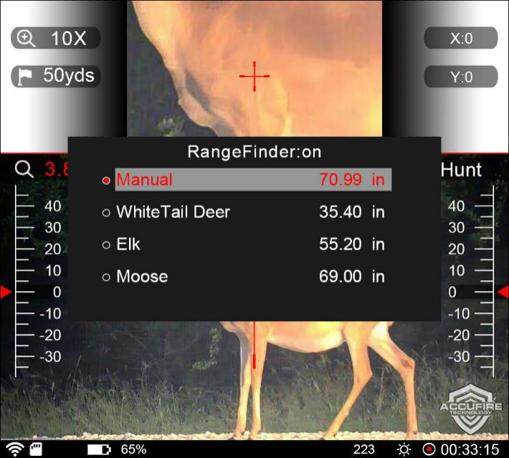
Click the selected record and check the selection box to display. At this time, the parameter value can be modified by rotating the knob. After modification, if you do not want to select the target, click exit selection. In the check state, the long press means to select the target and to return to the home screen; in the ticked state.
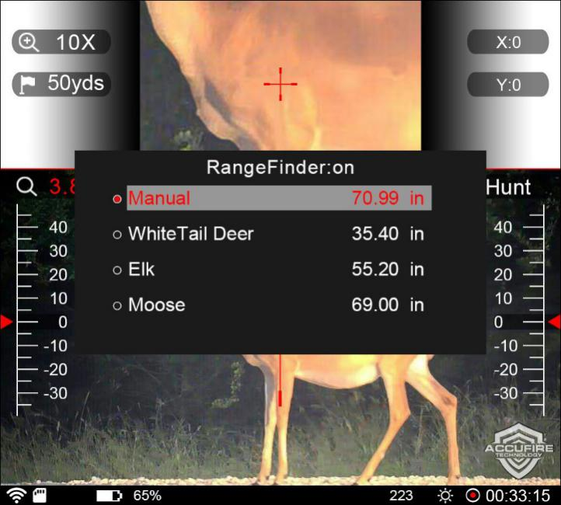
Distance measuring ruler. When measuring distance, the inner edge of the ruler line is used to match the bottom and top of the object. The color of the ruler changes with the color of the cross; this function is effective both in dense bit mode and automatic computation mode.
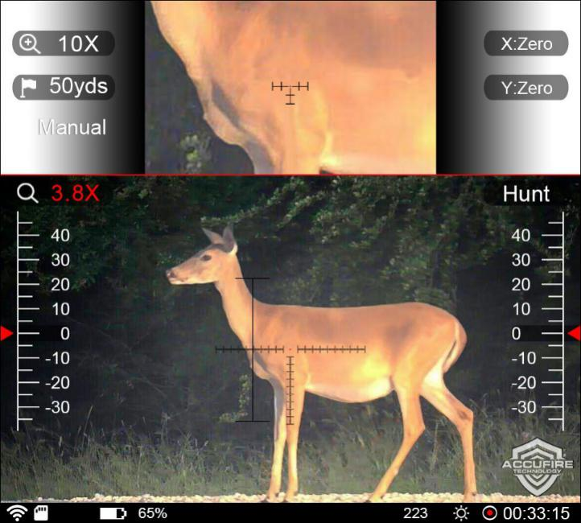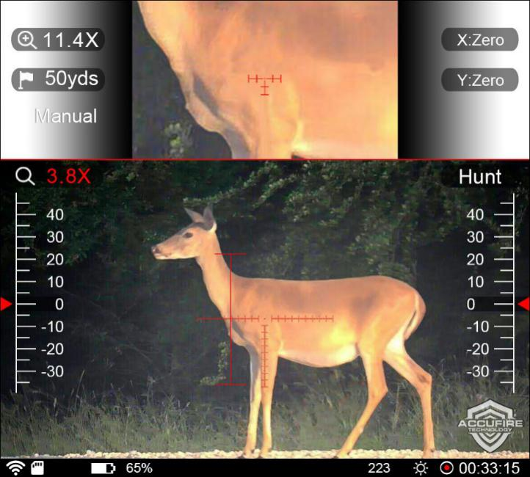
After returning to the main interface, click the distance option and turn the knob to start the distance measurement.
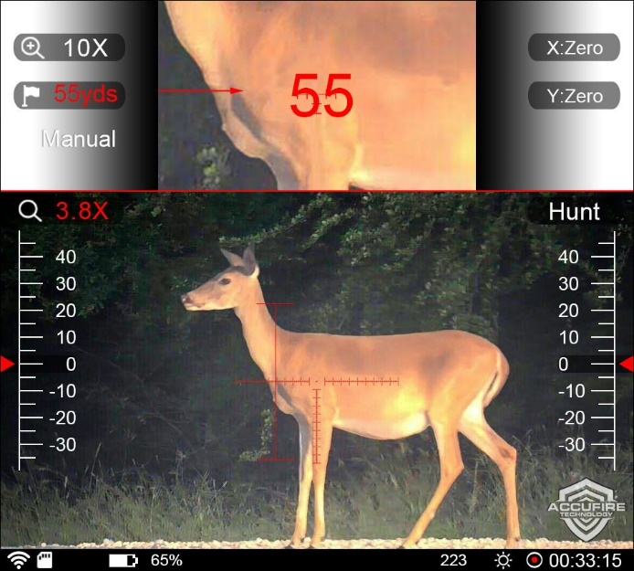

Software Upgrade
Enter the home menu item, select the software upgrade icon, and click the knob; after the upgrade is successful, the sight will restart automatically; and if the SD card is not inserted or the upgrade file is damaged, the sight prompts “the upgrade file does not exist”.
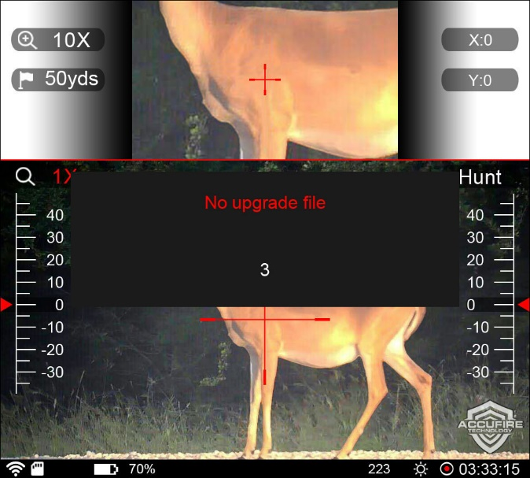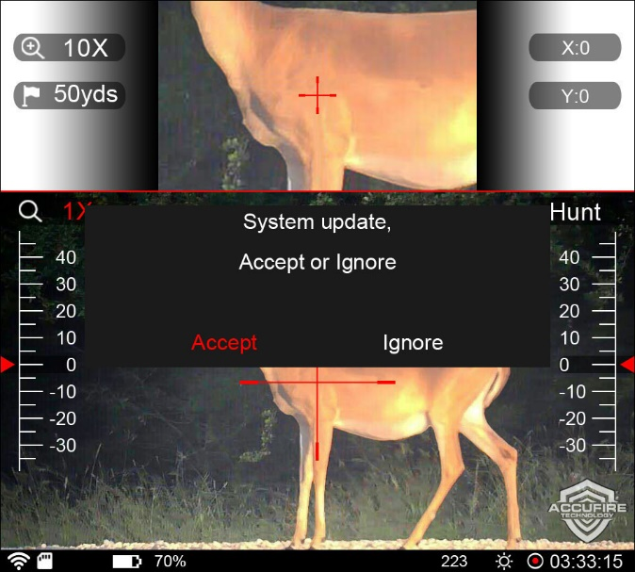

Day and Night Mode Switching
Enter the home menu item, select day and night mode switching, and click the knob to complete the mode switching.
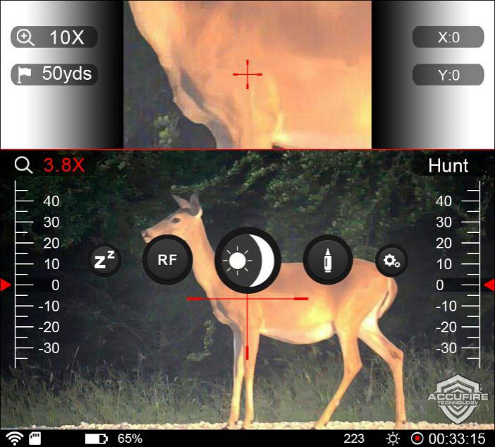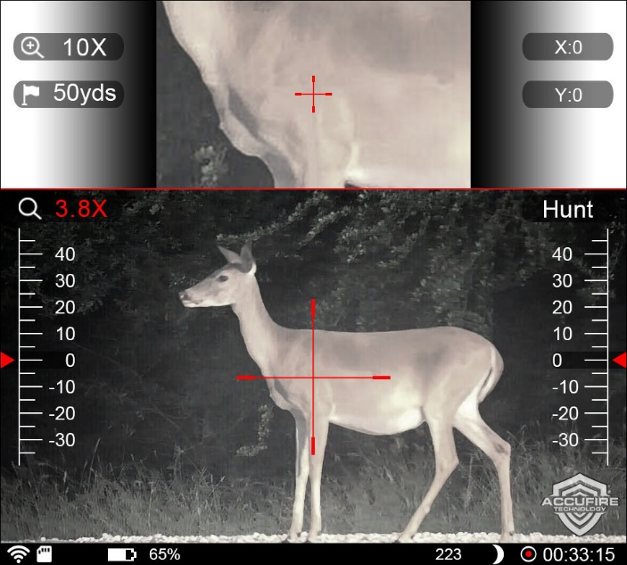

Bullet Type Input
Enter the home menu item, select the bullet type, and click the knob, display the bullet list interface.
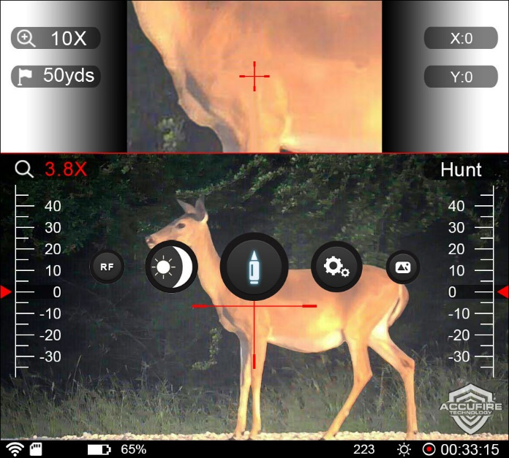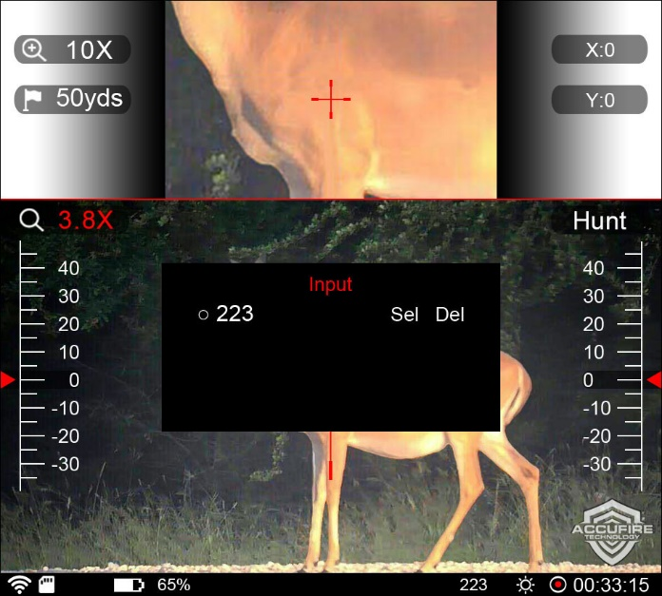
Click "input" to add a new bullet, You can enter any bullet model. The bullet type can contain numbers or symbols, the numbers are 0-9, the symbols are"- /. x", four symbols in total, the bullet type can record up to 7-digit symbols. Rotate the knob to select the input position, click the knob, then rotate the knob to select the corresponding symbol, and click the knob again to complete the input of one-digital symbol. After the type input is completed, move to "Ok" and click the knob button, then the trajectory setting "3006" is completed, and directly return to the main interface.
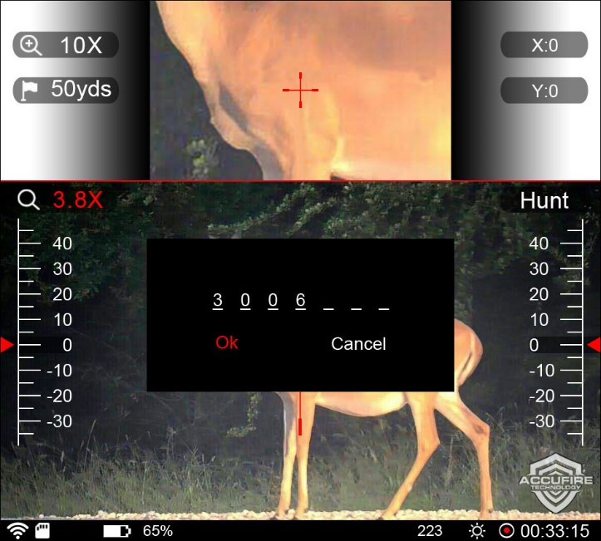
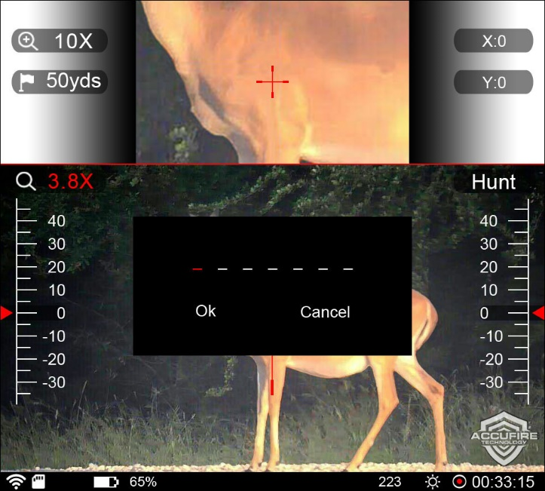

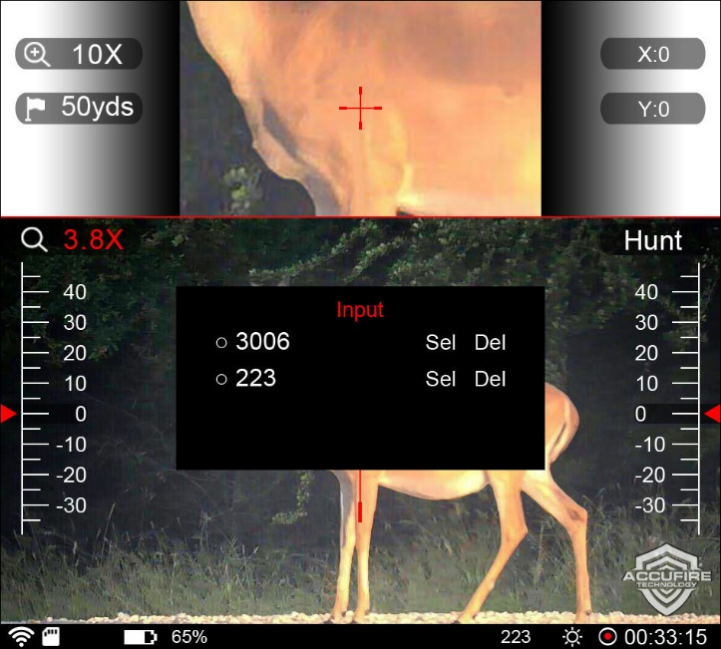

If the added bullet already exists, such as 3006, a prompt box will pop up, indicating that the bullet already exists and adding the input again.
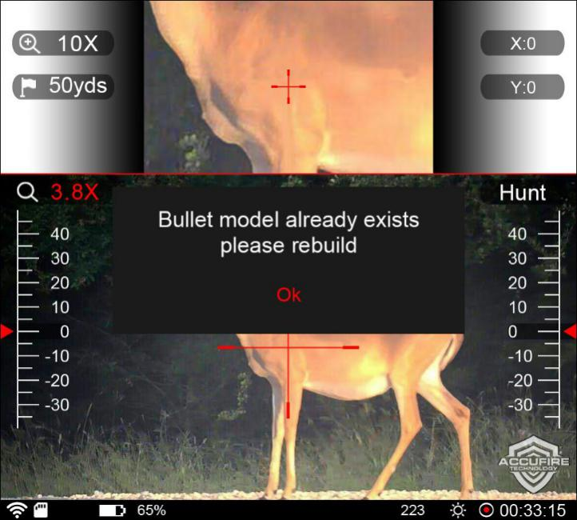
For users who need to input multiple identical bullet models, symbols can be added to distinguish bullet models, such as 30061 or 3006-1.
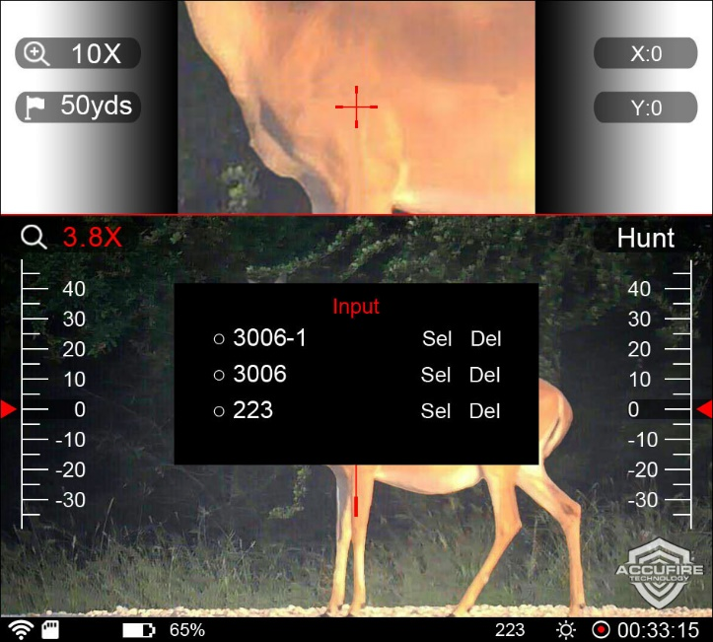

Rotate the knob to select bullets or delete bullets.
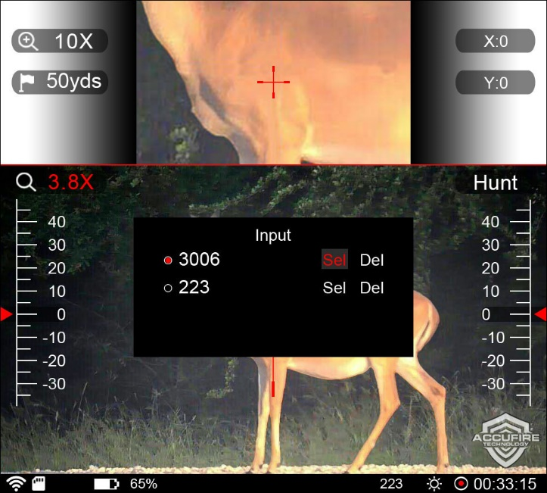

Click the knob to edit.
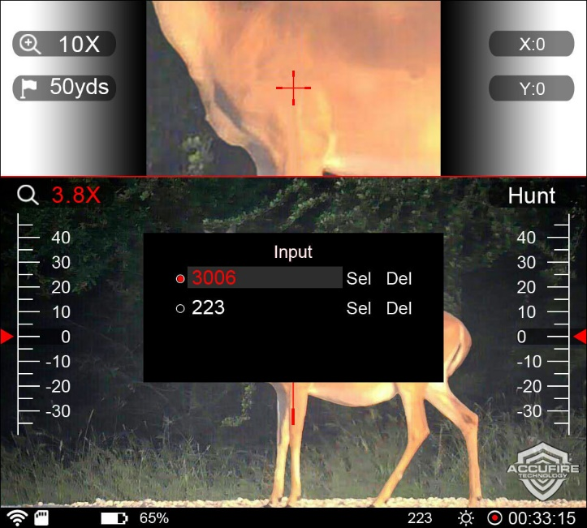

Select rotate the knob to switch in the editing state； “Sel” represents selection, “Del” represents deletion; after selecting Sel, set the bullet replacement directly and return to the main interface; select Del, and the confirmation prompt box will pop up; click Ok to confirm deletion, and click Cancel to cancel the deletion operation and return to the list.

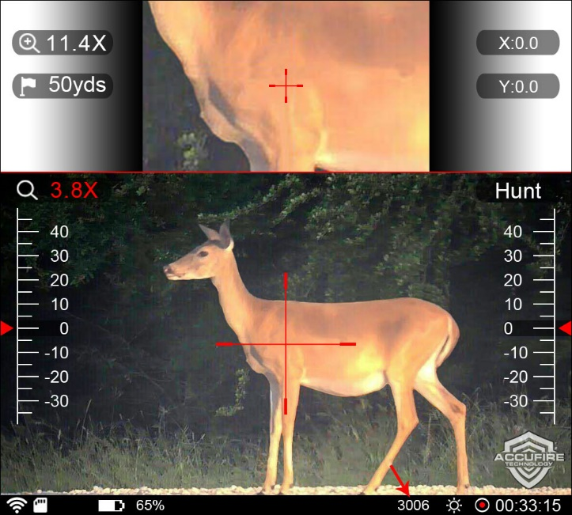

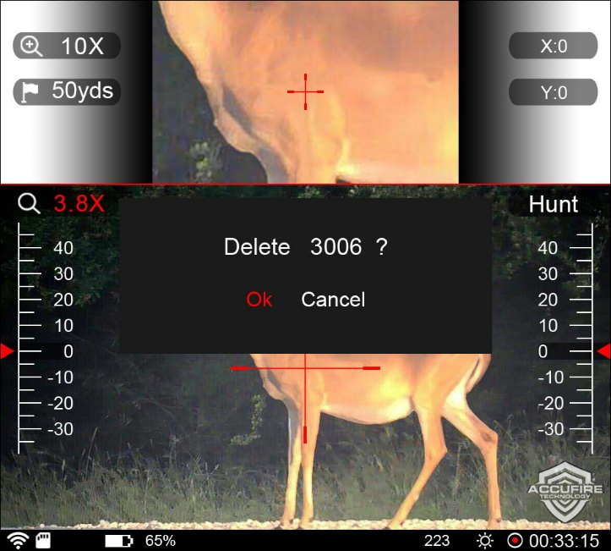
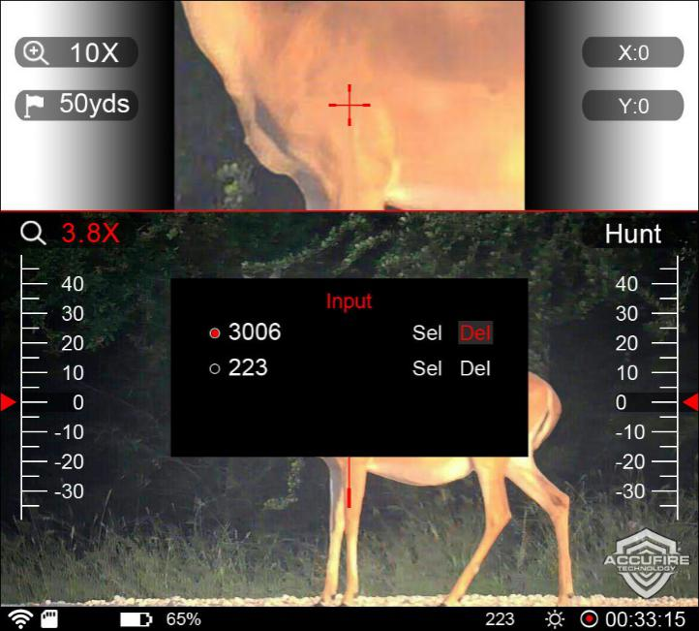

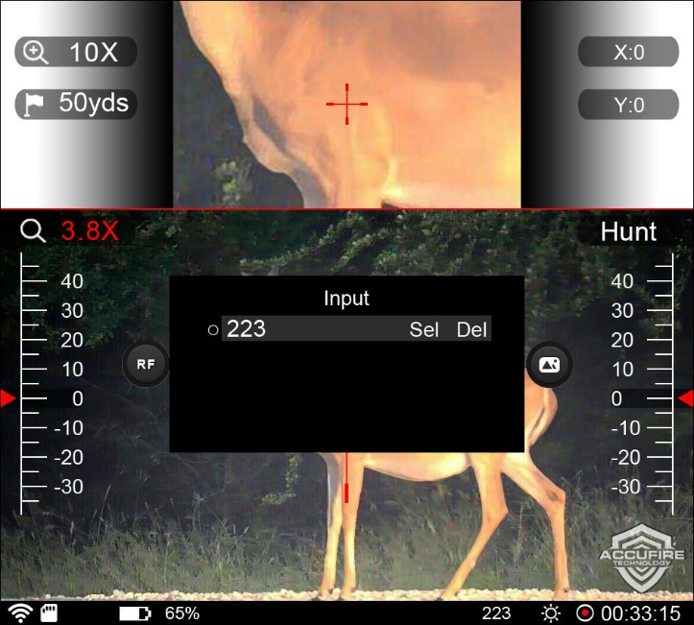

When there is only one bullet of the model in the list or the selected bullet is the current bullet, the delete button is gray, indicating that deletion is not allowed.
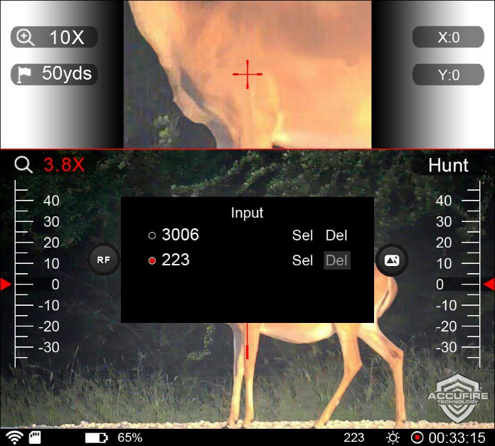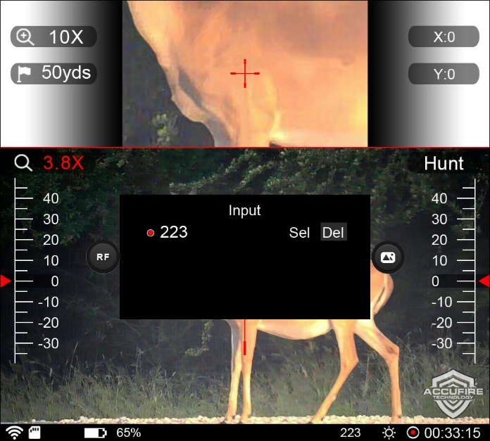
In the list interface, long press to exit and return to the main interface when editing any bullets is not selected.

System settings

WiFi Setting
Open the WiFi or close the WiFi.
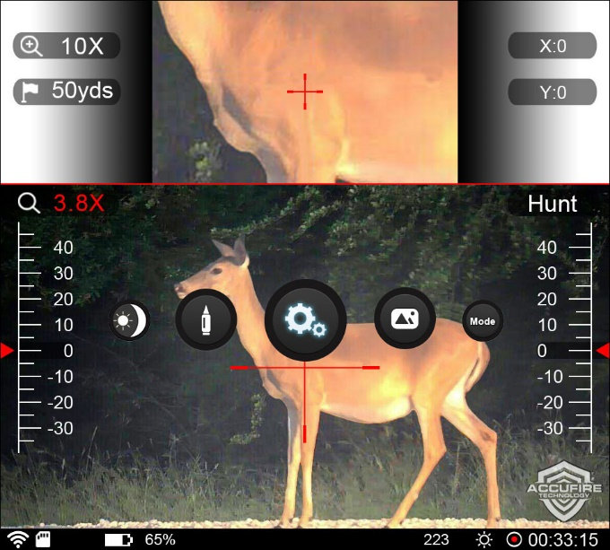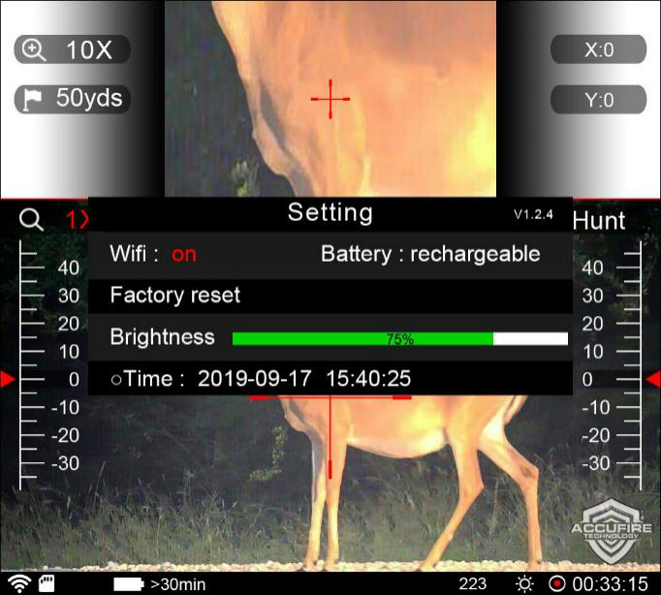

Battery type
Battery type, set the battery currently used as rechargeable battery or non rechargeable battery.
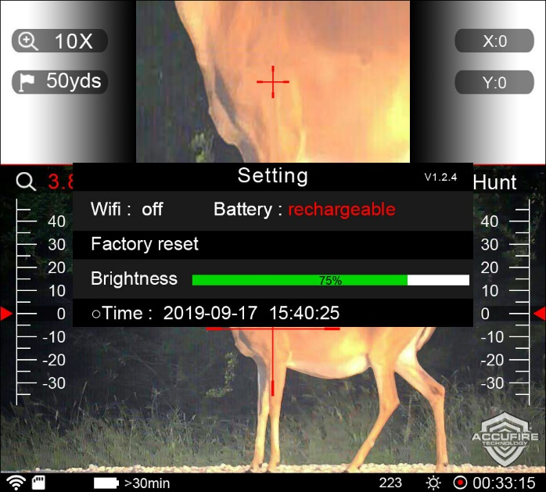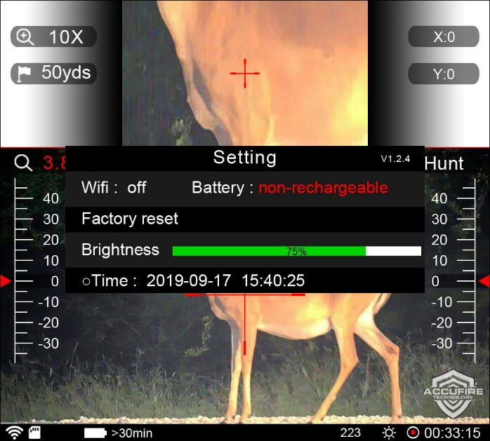

Factory Reset
Click the knob, pop-up the prompt box, select “accept” to ensure that the sight restores the factory settings, and select “Ignore” to ensure that it quits the current operation.
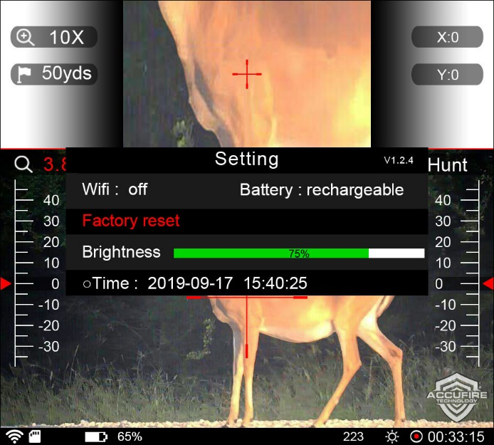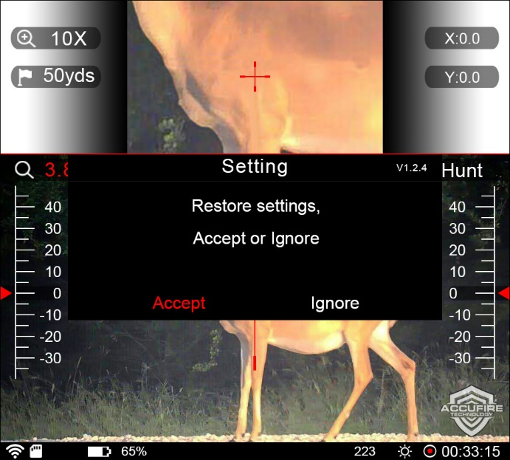

Screen Brightness Setting
In the system setting option, rotate the knob to select “Brightness”, click the knob to enter the adjustment status, and rotate the knob to adjust the screen brightness. Screen brightness levels are 1%, 2%, 3%, 4%, 5%, 6%, 7%, 8%, 9%, 10%, 15%, 20%, 25%, 50%, 75% and 100%.
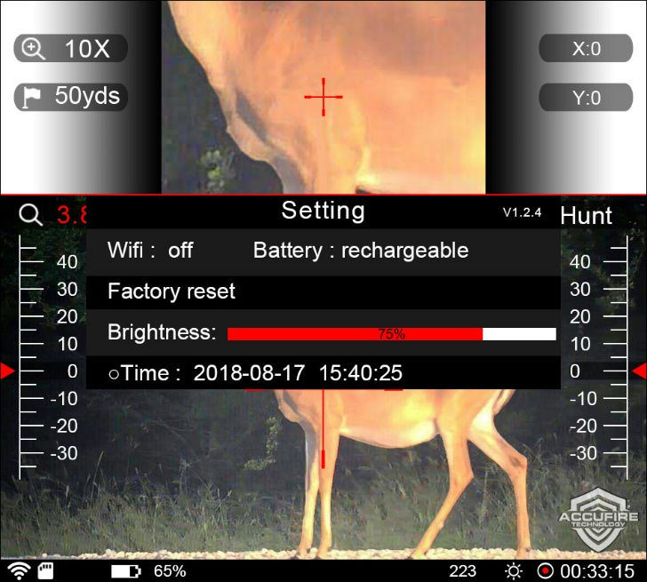

Quick Screen Brightness Adjustment
In the home screen, long-press the knob to pop up the home menu interface, and at this time, long-press and hold the knob for 2 seconds to enter the quick screen brightness adjustment mode, and rotate the knob to adjust the screen brightness. After the screen brightness adjustment is completed, long-press the knob to quit the quick screen brightness adjustment after about 3 seconds.

Time Setting
In the system setting option, rotate the knob to select the “Time” option, click the knob to enter the time setting. Rotate the knob to select the position to set the time, click to enter, rotate the knob to increase or decrease the value, and click again to quit the setting of this time position. As such, set the year, month, day, hour, minute, and second in this order.
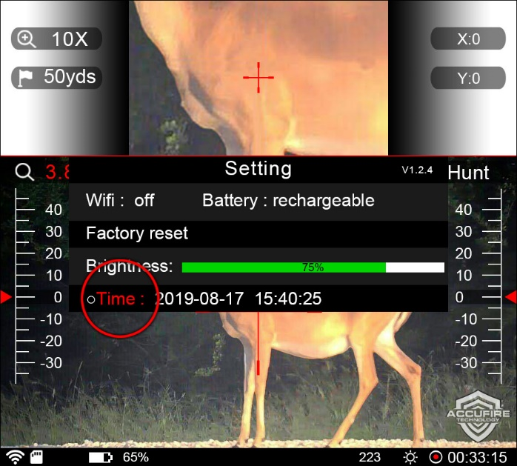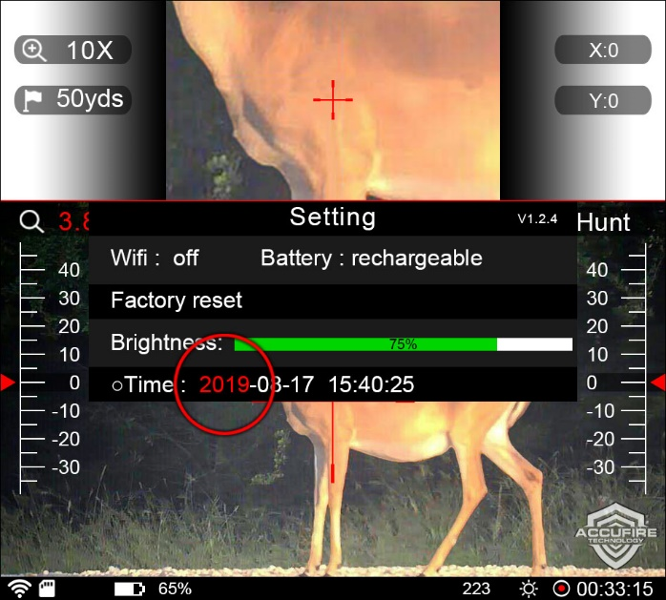

Picture preview
Long press the knob and the main menu pop up; select the picture preview icon, and click. If the SD card does not exist or there is no picture, it will prompt “No Picture”. If there is, it will enter the Picture list and the pictures will upload in sequence; before the uploading is finished, the button operation cannot be conduct. In the picture list, a maximum of 12 thumbnails can be displayed at one time, with 3 labels at the bottom of the picture, i.e. “Previous”, “Next” and “current page/total pages”. Click “Previous” to go to the Previous page, and click “Next” to go to the Next page. If the current page is the first page, “Previous” is the gray unclickable state; if the current page is the last page, “Next” is the gray unclickable state.
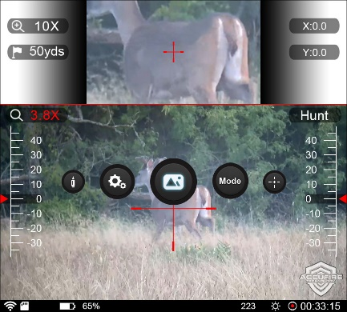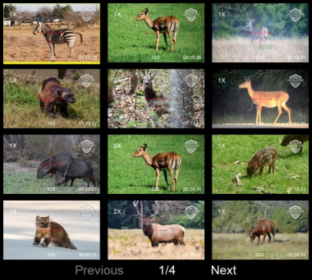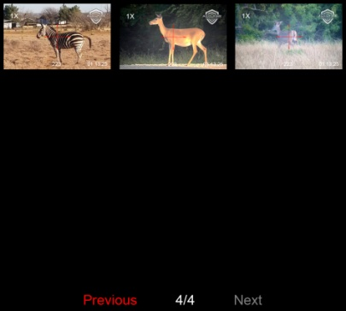
Rotate the knob and select the picture. The background of the selected picture is yellow. Click the knob to display the large picture. In the big picture preview interface, the picture is displayed in the center, and the label at the bottom shows “the current picture/total number of pictures”. In the big picture preview interface, rotate the knob to switch the picture preview.
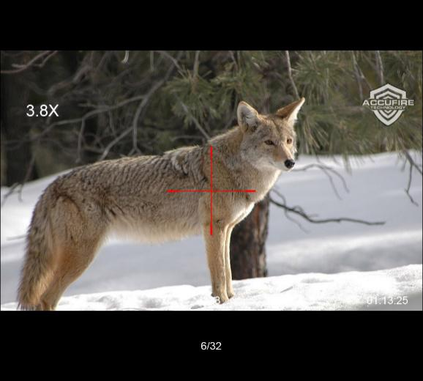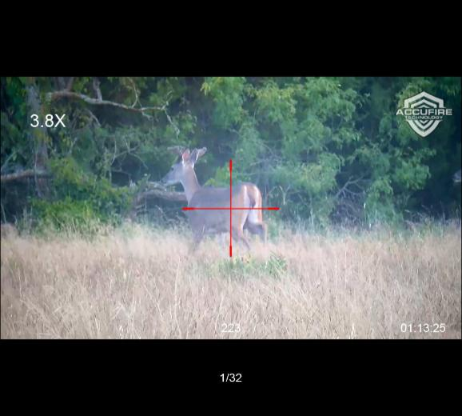
In the picture preview interface, long press the knob to return to the picture list interface. In the picture list interface, long press the knob to return to the main interface. In the Picture list screen or the big Picture preview screen, if you pull out the SD card, it will prompt “No Picture” to exit the preview and return to the main screen.
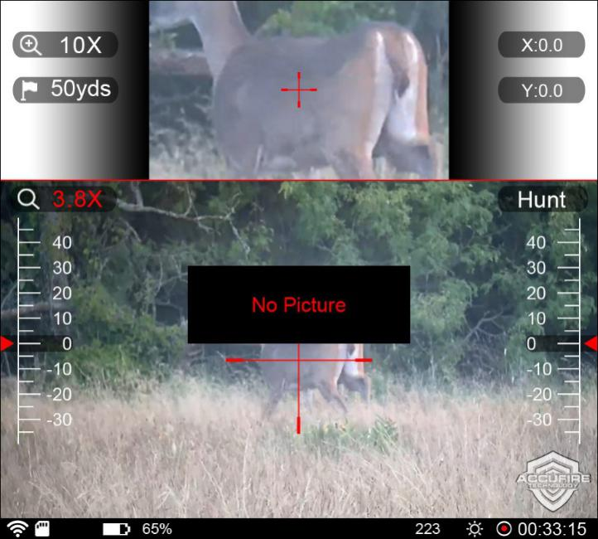

Mode selection
Click the mode selection menu, the mode selection interface will pop up; turn the knob to switch and select, and click ok to change the mode. If you do not want to set the mode, long press to exit.
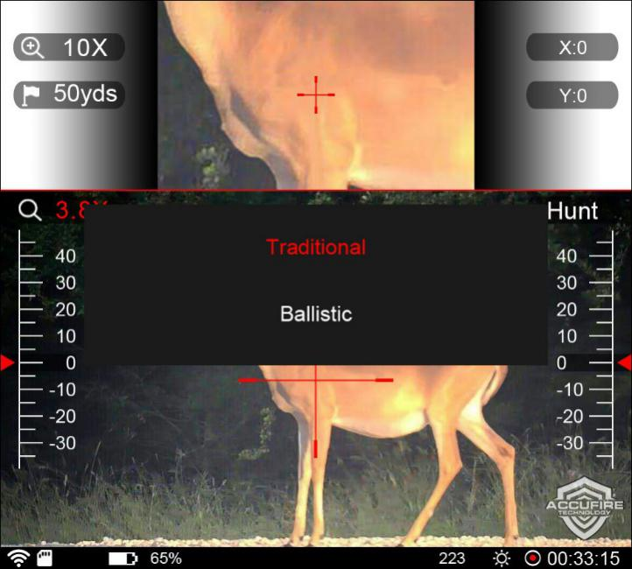

Mobile Application
THERE WILL BE BRIEF INTRODUCTION AFTER OPENNING THE APP.
- Click “Connect Device” on the home page to enter the live preview interface. If the hotspot exists and is successfully connected, the live view will be displayed.
- If the hotspot does not exist or has not been successfully connected, the red disconnect logo will be displayed in the top-right corner of the page. If the current system is ios, you need to manually enter the settings -> WLAN -> Connect Hotspot of the ios. If the current system is Android, you need to click the red logo in the top-right corner such that the WiFi list will be populated, select the hotspot for connection, the connection password is 00000000，and automatically return to the live preview interface after the connection is successful.
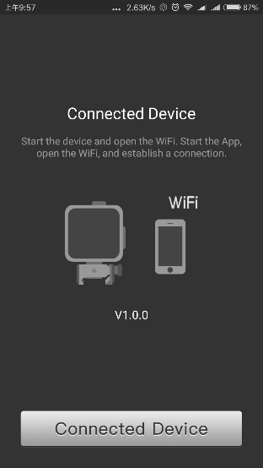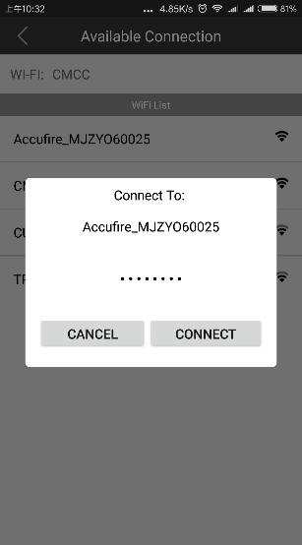
Figure 1 Figure 2
Real-time preview page. The page shows the views from camera in real time.
 Video/Photo switching.
 Video/photo file management menu. After clicking, it will go to the page as shown in Figure 4.
 Start video/take photo
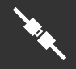 Connection status indicator
When the connection is normal, it will show .
When the connection is abnormal, it will show.
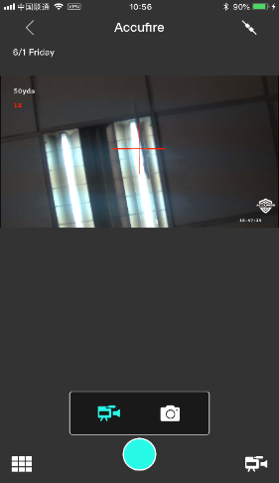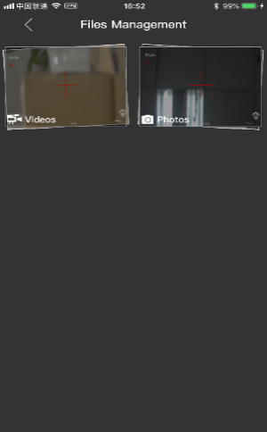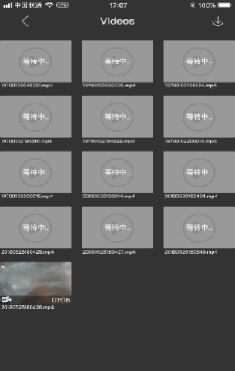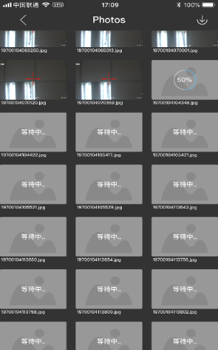
Figure 3 Figure 4 Figure 5 Figure 6
The functions of video file management:
- Download all video files: it will download all the video files when clicking 
- Download one video file: it will download a single file when you click an un-downloaded video file.
- Resume download: it will resume the download when clicking a pause download video file.
- Video playing: when clicking a downloaded video file，it will go to the video play page as shown in figure 7.
- Video clipping: In figure 7, after clicking the “Clip” button, it will go to the clipping page as shown in figure 8.
- Delete video file: when long-pressing any one video file, it will switch to the video choose status. You can choose all files when clicking the top-right button, or a part of files when clicking each file which plan to delete. After clicking the “delete” button on the bottom, all the chosen files will be deleted.
(this function is ongoing)

The functions of photo management:
- Download all photos: it will download all the photos when clicking
- Download one photo: it will download a single photo when you click an un-downloaded photo file.
- Delete Photo: the operation is as same as deleting video file.
- Photo sharing.

- Video clipping: you can clip any one downloaded video file after clicking it on video play page. The clipping page is as shown in figure 8. The minimal of video file is 3s, and the maximal is 15s. You can choose the time duration based on the start and end indictor on the bottom of page.
- After choosing the start and end time, you can click “next” button to go to the sharing page. The sharing target button is on the top-right of page as shown in figure 9. Currently, there is a support for sharing it to YouTube and Facebook.
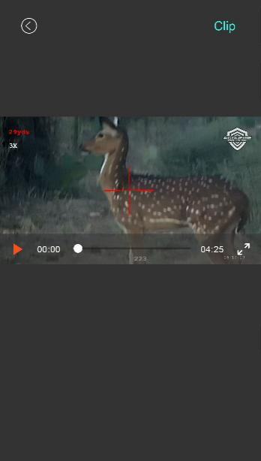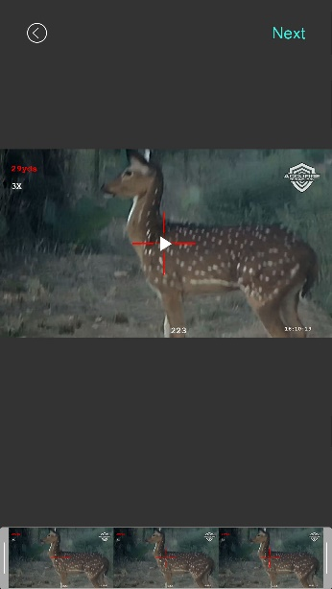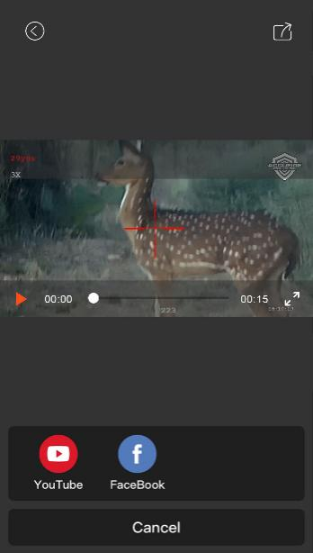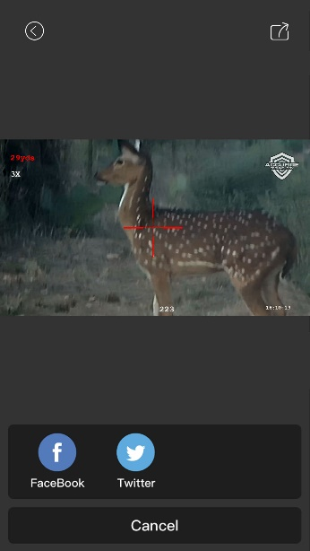
Figure 7 Figure 8 Figure 9 Figure 10
Photo sharing: you can share any one photo when clicking it on the photo management page, the sharing page is as shown in figure 10. Currently, there is a support for sharing it to Facebook and Twitter.

